Java file writer and file reader class

->used to write and read data from text file .

->character oriented classes.

Read content from file ->

import java.util.*;  
import java.io.FileOutputStream;  
import java.io.*;  
  
public class Pwr {  
   
 public static void main(String args[]) throws IOException {  
 File infile=new File(**"d:**\\**testout.txt"**);  
 FileReader fr=null;  
 try{  
fr=new FileReader(infile);  
int ch;  
while((ch=fr.read())!=-1) {  
 System.*out*.println((char) ch);  
  
}  
 }catch(Exception e){System.*out*.println(e);}  
fr.close();  
  
}}

output

W

e

l

c

o

m

e

t

o

j

a

v

a

T

p

o

i

n

t

Java SequenceInputStream Class declaration->

Java SequenceInputStream class is used to read data from multiple streams. It reads data sequentially (one by one).

## Constructors of SequenceInputStream class-

## 

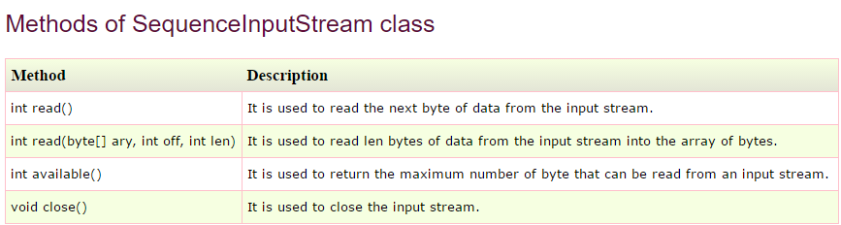

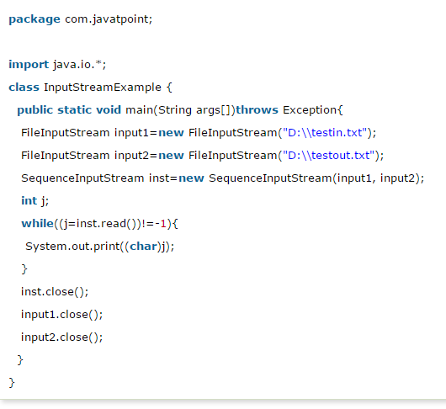

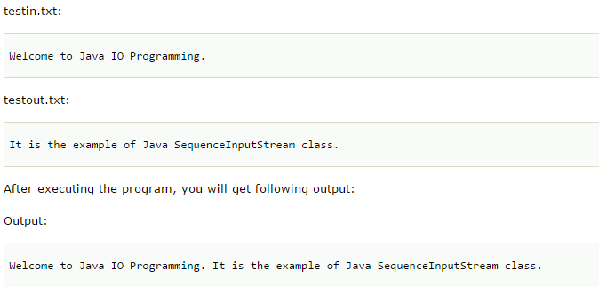

Write content from two file to another file->

